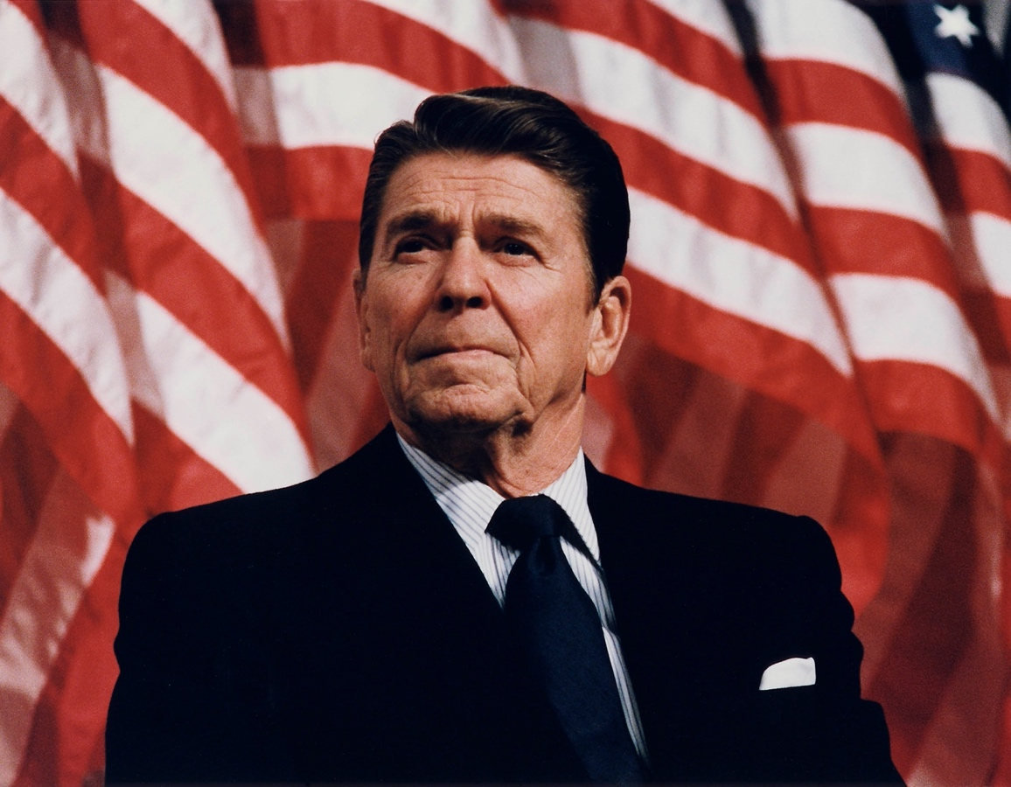

Ronald Reagan Dedications


Table of Contents
Alabama 4
Arizona 5
California 6
Colorado 12
District of Columbia 13
Florida 15
Georgia 16
Idaho 16
Illinois 17
Indiana 21
Iowa 21
Kansas 22
Kentucky 22
Louisiana 22
Mississippi 23
Missouri 23
Montana 23
Nebraska 24
Nevada 24
New Hampshire 24
New Jersey 24
New York 25
North Carolina 25
North Dakota 25
Ohio 26
Oklahoma 26
Pennsylvania 27
South Carolina 27
South Dakota 27
Tennessee 27
Texas 28
Utah 29
Virginia 30
Wisconsin 30
International Dedications 31

Total Dedications: 183
Domestic Dedications: 159
International Dedications: 24

******

Alabama

Name | Location | Year of Dedication | Additional Information
Ronald Reagan Spirit of America Field | Decatur, AL | 2004 | Ronald Reagan visited the field for a speech on July 4, 1984
Ronald Reagan Memorial Boulevard | Dothan, AL | 2005 | Ronald Reagan’s motorcade traveled this road when he visited Dothan on July 10, 1986.
Ronald Reagan Memorial Highway | Houston County, AL | 2004 | A 70-mile portion of Interstate Highway 65 between Birmingham and Decatur.
Ronald Reagan Bust | Northport, AL | 2006 | Ronald Reagan visited the Northport McDonald’s on October 15, 1984

Arizona

Name | Location | Year of Dedication
Ronald Reagan Road | Kingman, AZ
The Ronald Reagan Fundamental School | Yuma, AZ | 1984

California

Name | Location | Year of Dedication | Additional Information
Ronald Reagan Park | Anaheim, CA | 2001 | Formerly Toyon park
Ronald Reagan Elementary School | Bakersfield, CA | 1998
Ronald Reagan California Republican Center | Burbank, CA | 1996 | The headquarters of the California State Republican Party.
Ronald Reagan Elementary School | Chowchilla, CA | 2007
Reagan Educational Center | Clovis, CA | 2007
Reagan Educational Center Timberwolves Foundation | Clovis, CA | 2007
Reagan W. Elementary School | Clovis, CA | 2006
Ronald Reagan Park | Diamond Bar, CA
Ronald Reagan Academy | Dinuba, CA | 2004
Ronald Reagan Community Center | El Cajon, CA | 2004
Ronald Reagan Elementary School | Kingsburg, CA | 2007
Ronald Reagan Building | Los Angeles, CA | 1990 | The “Ronald Reagan State Office Building”
The Reagan Room, The Jonathan Club | Los Angeles, CA | 2001 | Ronald Reagan was an honorary member of the Jonathon Club.
Ronald Reagan Distinguished American Award, The Jonathan Club | Los Angeles, CA | 1991 | Presented annually by the Jonathon Club, Los Angeles
The Reagan Center | Los Angeles, CA
The Ronald Reagan Suite at the Century Plaza Hotel | Los Angeles, CA
Ronald Reagan UCLA Medical Center | Los Angeles, CA | 2007 | 2000
Ronald Reagan Terrace, Los Angeles Country Club | Los Angeles, CA | 2005 | President Reagan was a member of the Los Angeles Country Club
The Ronald Reagan Professor, Pepperdine University School of Public Policy | Malibu, CA | 1999
Ronald Reagan Elementary School | Palm Desert, CA | 2006
Ronald Reagan Statue | Sacramento, CA |  | 8 foot statue in the State Capitol
Ronald Reagan Golden Palm Star | Palm Springs, CA | 1997 | A Golden Palm Star on the Palm Springs Walk of Stars
Ronald Reagan Boulevard | Point Mugu, CA | 2005 | While Ronald Reagan was President, he and Nancy Reagan flew in and out of this base to visit their ranch near Santa Barbara
Ronald Reagan Elementary School | Sanger, CA
USS Ronald Reagan (CVN 76) | San Diego, CA | 2001 | Nuclear-powered aircraft carrier
Ronald Reagan Room, USS Ronald Reagan | San Diego, CA | 2001 | A museum featuring Ronald Reagan movie memorabilia and a piece of the Berlin Wall.
Ronald Reagan Veteran Memorial Building, Post #384 of the American Legion | San Francisco, CA
Ronald W. Reagan Federal Courthouse | Santa Ana, CA | 1999
Reagan Room, Fess Parker’s Doubletree Hotel | Santa Barbara, CA
Reagan Ranch Leadership Academy | Santa Barbara, CA | 1998 | Affiliated with the Young America’s Foundation, current owners of Rancho del Cielo (Ronald Reagan’s former ranch near Santa Barbara).
Ronald Reagan District of the Boy Scouts of America | Simi Valley, CA
Ronald Reagan Presidential Foundation | Simi Valley, CA
The Ronald Reagan Presidential Library and Center for Public Affairs | Simi Valley, CA | 1991 | The Ronald Reagan Library is a unit of the National Archives and Records Administration, a federal agency. The building is also home to the Ronald Reagan Presidential Foundation
Simi Valley – “Home of the Ronald Reagan Presidential Library” | Simi Valley, CA | 2004 | The official motto of Simi Valley, home to the Reagan Presidential Library
Reagan Road | Sylmar, CA | 2004 | Near Olive View UCLA Medical Center
Reagan Legacy Foundation | Toluca Lake, CA |  | Founded by Ronald Reagan’s son Michael “to advance the causes President Reagan held dear and to memorialize the accomplishments of his presidency.”
The Ronald W. Reagan Missile Defense Site | Vandenberg Air Force Base, CA | 2006
Ronald Reagan Freedom Award |  | 1992 | Award presented by the Ronald Reagan Presidential Foundation, to those “who have made monumental and lasting contributions to the cause of freedom…. who [embody] President Reagan’s lifelong belief that one man or woman truly can  make a difference.”
Ronald Reagan Sports Park | Temecula, CA | 2004 | Initial funding and construction came entirely from the community, without any government involvement.  Reagan cited in the park in a 1983 speech, as an example of what Americans could accomplish through voluntary effort. A bronze statue of  Reagan was dedicated in 2012
The Ronald Reagan Pub, The Ronald Reagan Presidential Library | Simi Valley, CA | 2005 | Interior building found in the library’s Air Force One Pavilion
Ronald Reagan Presidential Suite, Westlake Village Inn | Westlake Village, CA | 2000
Ronald Reagan Elementary School | Wildomar, CA | 2005
Ronald Reagan Freeway | Ventura County, CA | 1994 | State Route 118
Ronald Reagan Day (February 6) | State of California | 2010 | Official state commemoration of Reagan’s birthday, held annually beginning with the 100th anniversary  of his birth in 2011.
Statue of Governor Ronald Reagan | Simi Valley, CA | 2016 | Within the Ronald Reagan Presidential Library and Museum

Colorado

Name | Location | Year of Dedication | Additional Information
Ronald Reagan Highway | El Paso County, CO | 2001 | A portion of Interstate Highway 25
The Reagan Suite | Denver, CO |  | Suite in the Brown Palace Hotel. President Reagan stayed in this suite when visiting Denver in 1981.

District of Columbia

Name | Location | Year of Dedication | Additional Information
Ronald Reagan Presidential Foundation and Institute | 850 16th St, Washington, DC 20006 | 2022
Ronald Reagan Building and International Trade Center | 1300 Pennsylvania Ave NW Washington, DC 20004 | 1998
Ronald Reagan Chair in Public Policy, Heritage Foundation | Washington, DC 20002
Ronald Reagan College Leaders Scholarship Program, the Phillips | Washington, DC 20001 | 2006 | This program was established in 1999 as the Future Leaders Program. It acquired its current name effective academic year  2006-2007.
Ronald Reagan Institute of Emergency Medicine | George Washington University Hospital | 1991 | Located at the hospital to which Reagan was taken immediately after the March 30, 1981 assassination attempt on his life.
The Ronald Wilson Reagan Republican Center | Washington, DC 20002 |  | Home of the National Republican Senatorial Committee
Bronze Statue of President Reagan | Washington, DC 20004 | 2009 | Statue maintained in the Rotunda of the U.S. Capitol
Bronze Medallion of Ronald Reagan | Ronald Reagan Building and International Trade Center, Washington, D.C. 20004 | 2009
Bronze Statue of President Reagan | Ronald Reagan Presidential Foundation and Institute
The Ronald Reagan Conference Room | Americans for Tax Reform, Washington, DC

Florida

Name | Location | Year of Dedication | Additional Information
Ronald W. Reagan Doral Senior High School | Doral, FL
Ronald Reagan Parkway | Hillsborough and Polk Counties, FL | 2004
Ronald W. Reagan Memorial Highway | Jacksonville, FL | 2009 | Portion of State Route 9A
Ronald W. Reagan Presidential House | Florida International University, Miami, FL | 2007 | Residence of the university’s President. Was given its present name by the Florida legislature.
Ronald Reagan Avenue | Miami, FL
Reagan Avenue | Seffner, FL
Ronald Reagan Boulevard | Seminole County, FL |  | Section of State Route 427 from Sanford to Maitland
Ronald W. Reagan Post Office Building | West Melbourne, FL | 2000
Ronald Reagan Turnpike |  | 1998
Ronald Reagan Boulevard | Seminole County, FL

Georgia

Name | Location | Year of Dedication
Ronald Reagan Drive | Augusta, GA | 2000
Ronald Reagan Park | Lawrenceville, GA | 2004
Ronald Reagan Parkway | Forsyth and Gwinnett Counties, GA

Idaho

Name | Location | Year of Dedication
Ronald Reagan Elementary School | Nampa, ID | 2002

Illinois

Name | Location | Year of Dedication | Additional Information
The Ronald and Nancy Reagan Research Center, The Alzheimer’s  Association | Chicago, IL | 1995
Ronald Reagan Boyhood Home | Dixon, IL | 1984 | Ronald Reagan lived in this house during part of his teenage years (1924-1928).  It now operates as a museum. The home  was named a historic site in 2002.
Ronald Reagan Bridge | Dixon, IL
Reagan Room, First Christian Church | Dixon, IL |  | Ronald Reagan and his mother attended this church during their years in Dixon
Reagan Way (Hennepin Avenue) | Dixon, IL | 2002 | Street on which the Reagan Boyhood Home is located.  Acquired the designation “Reagan Way” when the Boyhood Home was designated a National Historic  Site.
Ronald Reagan Equestrian Statue | Dixon, IL
Ronald W. Reagan Middle School | Dixon, IL | 1996
Reagan Drive | Eureka, IL | 1979 | Runs along the southern edge of Eureka College, Reagan’s alma  mater.
Reagan Physical Education Center | Eureka College | 1961 | Originally dedicated as “The Reagan Center,” in honor of both Ronald Reagan and his brother Neil (Moon). It acquired its current name in  1970.
Ronald Reagan Peace Garden | Eureka College | 2000 | The garden is home to a piece of the Berlin Wall.
The Ronald W. Reagan Museum at Eureka College | Eureka College | 1992 | A museum that covers President Reagan’s entire life from childhood to the nation’s highest office.
Ronald W. Reagan Leadership Program | Eureka College | 1982
The Ronald W. Reagan Society of Eureka College | Eureka College |  | Maintains the Reagan Museum, Peace Garden, and Leadership Program at Eureka College.
Ronald Reagan Home | Galesburg, IL |  | Ronald Reagan and his family lived in this house ca. 1915- 1916, during part of their time in Galesburg.
Ronald Reagan Exhibit | Monmouth, IL |  | The Monmouth area Chamber of Commerce maintain an educational exhibit on the former Presidents life. Reagan lived in Monmouth during part of his childhood (1917-1919).
Ronald Reagan Home | Monmouth, IL |  | A historical marker in front of this house notes that Ronald Reagan lived  There with his family from 1918 to 1919.
Ronald Reagan Birthplace and Museum | Tampico, IL | 1980 | Ronald Reagan was born in an apartment rented by his parents. The apartment was named a National Historic Site in 2002.
Reagan Middle School | Tiskilwa, IL
Ronald Reagan Highway |  |  | U.S. Highway 14; runs from Chicago north to the Wisconsin state  line.
Ronald Reagan Memorial Tollway |  | 2004 | Portion of Interstate Highway 88. Runs just south of Dixon, where the Reagan Boyhood Home is located.
Ronald W. Reagan Trail |  | 2000 | Runs from Dixon, IL (location of the Reagan Boyhood Home), through Tampico (Reagan’s birthplace), to Eureka (home of Eureka College, which  Reagan attended).
Reagan Park | Tampico, IL | 1985 | When Reagan was three months old, he and his family moved into a house across the street from this park. They remained until Reagan was almost four years old. A bronze statue of Ronald Reagan as a 12- year-old boy was dedicated at the  park in 2013

Indiana

Name | Location | Year of Dedication | Additional Information
Ronald Reagan Expressway | Allen County, IN
Reagan Elementary School | Brownsburg, IN
Ronald Reagan Miracle Ranch on Sugar Creek | Markleville, IN | 2001 | An educational facility tailored to assisting children with disabilities.
Ronald Reagan Parkway |  | 2007 | North-south road between Interstate 70 and Interstate  74.

Iowa

Name | Location | Year of Dedication | Additional Information
Ronald Reagan Historical Marker | Des Moines, IA | 1999 | The marker marks a site where Reagan lived while working for radio station  WHO.

Kansas

Name | Location | Year of Dedication | Additional Information
Ronald Reagan Building | Wichita, KS | 2016 | Formerly an IRS building.

Kentucky

Name | Location | Year of Dedication | Additional Information
Ronald Reagan Memorial Parkway |  | 2007

Louisiana

Name | Location | Year of Dedication | Additional Information
Ronald Reagan Highway |  | 2004 | US Highway 190
Ronald Reagan Statue | Covington, LA |  | World’s largest Ronald Reagan Statue

Mississippi

Name | Location | Year of Dedication | Additional Information
The Reagan Hope Home | Jackson, MS |  | Located on a ranch that is part of the Mississippi Sheriffs’ Boys’ and Girls’  Ranches.

Missouri

Name | Location | Year of Dedication
The Reagan Hope Home | Columbus, MO
Ronald Reagan Drive | High Ridge, MO
Ronald Reagan Parkway | Lake St. Louis, MO
Ronald and Nancy Reagan Center for the Arts | Springfield, MO
Reagan Road |  | 2004

Montana

Name | Location | Year of Dedication
Ronald Reagan Post Office | Billings, MT | 2004

Nebraska

Name | Location
Ronald W. Reagan Elementary School | Omaha, NE

Nevada

Name | Location | Year of Dedication
Mount Reagan | Clark County, NV | 2014

New Hampshire

Name | Location | Year of Dedication | Additional Information
Mount Reagan (Mount Clay) | Presidential Range of the White Mountains, Coos County NH | 2014 | Located in the state’s Presidential Range. Was renamed “Mount Reagan” by act of the New Hampshire State Legislature.

New Jersey

Name | Location | Year of Dedication
Ronald Reagan Academy School No. 30 | Elizabeth, NJ | 2006

New York

Name | Location
Ronald Reagan Boulevard | Warwick, NY

North Carolina

Name | Location | Year of Dedication
Reagan Road | Lexington, NC
Ronald Reagan Highway | Jacksonville, NC | 2005
Ronald Reagan High School | Pfafftown, NC | 2005

North Dakota

Name | Location | Year of Dedication | Additional Information
Ronald Reagan Peace Through Strength Missile Silo Historic Site | Cooperstown, ND | 2008 | The last Minuteman missile launch complex in North Dakota, maintained as a memorial to  Ronald Reagan.

Ohio

Name | Location | Year of Dedication | Additional Information
Reagan Park | Medina, OH
Reagan Parkway | Medina, OH
Reagan Drive | Piketon, OH
Ronald Reagan Lodge at Voice of Freedom Park | West Chester Township, OH | 2004
Ronald Reagan Highway | Cincinatti, OH | 1997

Oklahoma

Name | Location | Year of Dedication | Additional Information
Ronald Reagan Elementary School | Norman, OK | 2021 | One of 15 public schools in Norman that are named after U.S. presidents
Ronald Reagan Statue | National Cowboy Hall of Fame | 1998

Pennsylvania

Name | Location | Year of Dedication
Reagan Drive | Ephrata, PA | 2006
Ronald Reagan Federal Building | Harrisburg, PA | 2004
Ronald Reagan Drive | Quakertown, PA | 2002
Bust of Ronald Reagan | Union League of Philadelphia, PA | 2014

South Carolina

Name | Location
Ronald Reagan Portrait | South Carolina State House

South Dakota

Name | Location | Additional Information
Ronald Reagan Statue | Rapid City, SD | Part of a collection of statues of all former U.S. Presidents.

Tennessee

Name | Location | Year of Dedication
Ronald Reagan Memorial Highway |  | 2004
North Rutherford YMCA Ronald Reagan Facility | Smyrna, TN | 2006

Texas

Name | Location | Year of Dedication | Additional Information
The Reagan Leadership Society | Texas A&M University | 1997 | A society dedicated to building student leadership for the Texas A&M campus and the community at large. Its student founder named the society in recognition of Reagan’s “ability to  communicate, his ability to inspire confidence, and his  kind personality.”
Ronald W. Reagan Middle School | Grand Prairie, TX
Ronald Reagan Avenue | Hickory Creek, TX
Ronald W. Reagan Building | Houston, TX |  | Building housing the Harris County government offices
Ronald W. Reagan Boulevard | Leander, TX
Ronald Reagan Road | San Antonio, TX
Ronald Reagan High School | San Antonio, TX | 2000
Ronald Reagan Public Library | San Antonio, TX | 2000
Ronald W. Reagan Boulevard | Leander, TX | 2004
Ronald Reagan Memorial Highway |  | 2005 | A portion of Interstate Highway 20 in Tarrant County.
Ronald Reagan Memorial Highway |  | 2005 | A portion of US highway 290 in Harris County

Utah

Name | Location | Year of Dedication
Ronald Reagan Academy | Springville, UT | 2005

Virginia

Name | Location | Year of Dedication | Additional Information
Ronald Reagan Washington National Airport | Arlington, VA | 1998 | Located across the Potomac River from Washington, DC.
Ronald W. Reagan Middle School | Haymart, VA | 2012
The Reagan Building | Richmond, VA
Ronald Wilson Reagan Memorial Highway | Prince William County, VA | 2005 | A portion of State Route 234.
Statue of President Reagan | Arlington, VA | 2011 | Found at the entrance of Ronald Reagan Washington National Airport

Wisconsin

Name | Location | Year of Dedication
Ronald Wilson Reagan College Preparatory School | Milwaukee, WI | 2005
Ronald Reagan Elementary School | New Berlin, WI | 2006
Ronald Wilson Reagan Memorial Highway | Chemung Township, WI

International Dedications

Name | Location | Year of Dedication | Additional Information
The Ronald Reagan Marine Railway | Pago Pago, American Samoa | 1985
Ronald Reagan Street | Prague, Czech Republic | 2011 | Located near the U.S. embassy.
“Grenada Salutes Ronald Reagan, Leader of Freedom” Commemorative Stamp Collection | Grenada | 1996 | Proceeds from sales go to the Ronald Reagan Scholarship Fund.
The Ronald Reagan Scholarship Fund | Grenada | 1996 | Fund is used to send students from Grenada to the United States for  study.
Ronald Reagan Statue | Grosvenor Square, London, England | 2011
Ronald Reagan Statue | Ballyporeen, Ireland | 2012 | Ballyporeen is the village from which Reagan’s father’s family came. President Reagan visited the village in 1984.
The Ronald Reagan – Main Street | Ballyporeen, Ireland
The Ronald Reagan Pub | Ballyporeen, Ireland |  | While the building still stands, the pub closed in 2004 and the following year its fittings and external signage were transferred to the Ronald Reagan  Presidential Library.
US Army Kwajalein Atoll/Ronald Reagan Ballistic Missile Defense  Test Site | Republic of the Marshall Islands | 1999
Ronald Reagan Statue | Rike Park, Tblisi, Georgia | 2011 | The bronze statue  depicts a smiling  Reagan sitting on a  bench with crossed  legs. It has an  inscription with a  quote from Reagan:  ‘Freedom is never  more than one  generation away  from extinction.”
Ronald Reagan Bust Statue | Budapest City Park, Budapest, Hungary | 2006
Ronald Reagan Bronze Statue | Freedom Square, Budapest, Hungary | 2006
Ronald Reagan Park | Gdansk, Poland | 2006 | The park includes a statue of President Reagan with Pope John Paul II
Ronald Reagan Square | Krakow, Poland | 2004
Rondo Ronalda Reagana (Ronald Reagan Circle) | Tarnow, Poland | 2000 | Traffic circle that connects Pope John Paul II Street with a street leading to the Church of the  Blessed Caroline.
Ronald Reagan Monument | Wroclaw, Poland | 2011
Ronald Reagan Roundabout | Wroclaw, Poland
Reagan Plaza | U.S. Embassy in Berlin | 1998 | Section of the U.S. Embassy in Berlin
Ronald Reagan Bronze Statue | U.S. Embassy in Berlin | 2019 | Bronze statue on  terrace overlooking  the site of the “Tear  Down This Wall”  speech.
Ronald Reagan Shipyard | Satala, American Samoa | 2013
Ronald Reagan Street | Kyiv, Ukraine | 2023
Ronald Reagan Alley | South Park, Sofia, Bulgaria | 2017
Bust of Ronald Reagan | South Park, Sofia, Bulgaria | 2017 | Found in Ronald Reagan Alley.
Rondo Ronalda Reagana | Szczecin, Poland | 2011

******

